1. Locate the EDS client folder – usually

*C:\Program Files (x86)\SuperOffice\modules\Adwiza\Expander Design Suite*

1. Go to the \Logging folder
2. Run the Adwiza.LogConfig.exe  
   *EDS – Expander – logging for Document templates  
   EDS – Intraweb – Used together with the designer special scenarios  
   EDS – OCX – EDS Windows version   
   EDS – Popup forms/main – enable both when debugging the popup functionality  
   EDS – Search – used for the EDS Search application*

Choose the area, click enabled and save

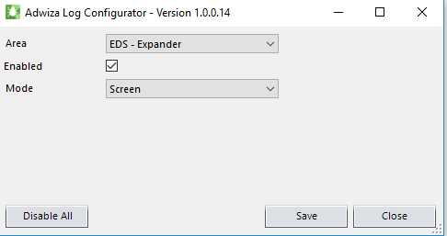

1. Run the Adwiza.LogViewer.exe
2. Start the EDS form/area you wish to debug
3. The LogViewer window will show the debug information
4. Once finished, remember to disable the log again by running the Adwiza.LogConfig.exe and press “Disable All”