When using EDS Frontend it is important to have the Refresh Snapshot task running on your backend server. The snapshot task ensures the Frontend is aware of new list entries, preferences and licenses. Without it you will often see errors like:

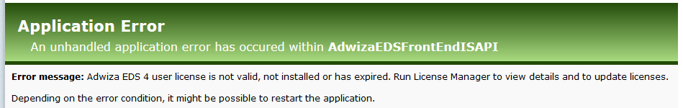

## Steps to enable the Snapshot task

1. Go to your EDS Server – usually where you have the Adwiza.Backend webservice installed
2. Start the EDS Designer
3. Go to the menu Setup 🡪 EDS.Web and EDS.FrontEnd setup
4. Switch to the second tab “Background tasks”
5. Enter the correct folder in the “Refresh snapshot task folder” – It should point to the folder where the EDS Server is installed and the \Refresh snapshot sub folder

You can click the “?” icon the “Hint” location is usually the correct location.

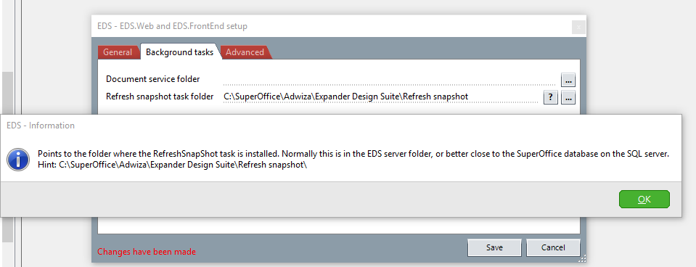

1. Press Save and exit the designer
2. Navigate to the refresh snapshot folder again
3. Right click the EDSRefreshSnapshot.exe file and choose “Run as administrator”
4. You will now have the Refresh snapshot task enabled and running. You can verify it directly in the Windows Task Scheduler.

