**EDS Online Install guide**

April 2017

Contents

Introduction 2

EDS Online install process 6

Setting up EDS Online 8

Deployment of the EDS Online Backend and EDS Online Frontend 9

BackEnd and FrontEnd Configuration 11

Frontend test 12

EDS Security 13

Toubleshooting 14

# **Introduction**

Before you begin, make sure that you have the following in place.

A valid subscription of the SuperOffice CRM Online version, including the username and password of the Administrator user of the SuperOffice CRM Online.  
  
RDP Access to a server of one the following types  
- Windows 2008, 2008 R2, 2012, Windows 2012 R2, Windows 2016  
- At least 8 Gb RAM, 2 core Processer, 500 Gb free hard disk space  
- Microsoft.NET Framework 4.6.2  
- The roles ‘Application Server’ and ‘Web Server (IIS)’ should be enabled  
  
The IIS should be accessible from the internet with a domain name, that has a SSL certificate on it.  
We recommend splitting the EDS deployment into 2 servers, one to act as the backend server, and another to act as a frontend server.

Before you begin

Go to <https://online.adwiza.com> and select the EDS Online app.

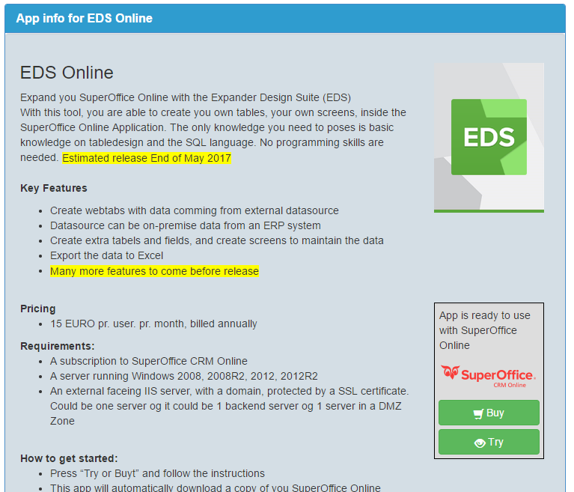

Click on the Try button and make sure that you are the Administrator of your SuperOffice Online Account.

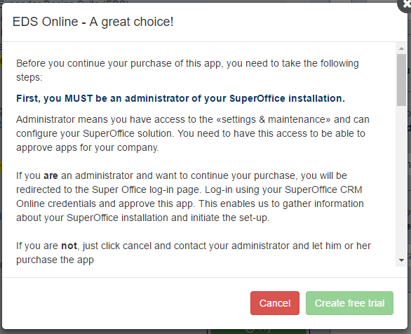

The EDS Online app also license the Mirroring service from SuperOffice, so you need to scroll down, using the Scrollbar to read and accept the Terms of the mirroring service.

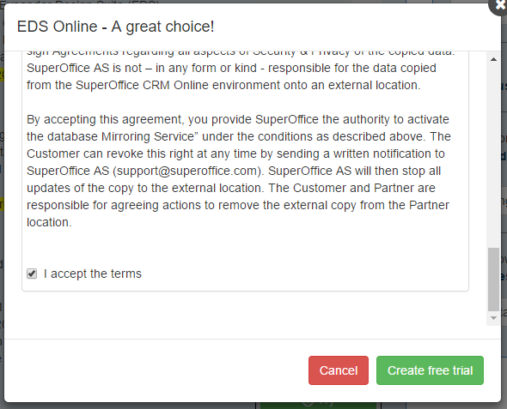

Click the ‘Create free trial’ and now will be redirected to the SuperOffice Online login screen to confirm, that you authorize the EDS Online app to provision itself toward your SuperOffice Instance and SuperOffice.

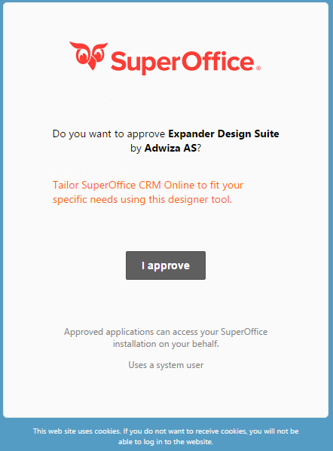

When the provisioning is done the Admin page of the EDS Online will appear. The administrator of the customer will also get an email with a username and password for the AOS platform.

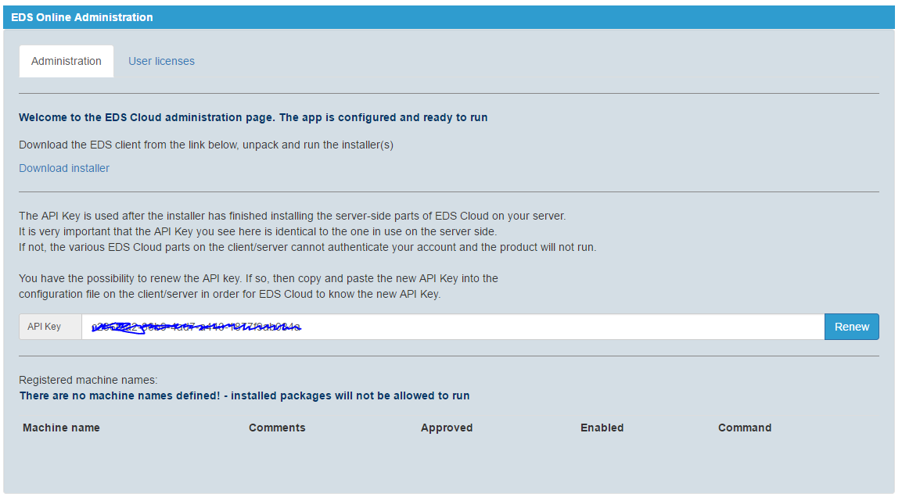

On this page, you can download the EDS Online installer that you will have to run on the Server where the EDS Online Designer should run.

The security in the EDS Online app comes in form of a two-factor authorization process. On the EDS Online admin page, you can see the unique API Key that was issued to provide a link between the local EDS Online installation and the AOS platform, and onwards to SuperOffice CRM Online.

It is very important to keep the API in a safe place, and not share this with anyone who is outside your organization. You will need the API to be able to install the software on the EDS Online Server.

# EDS Online install process

Download the installer and unzip on the server where the EDS Online should live and work. In this guide, we will assume that everything is installed on only one server, that has access to the internet and has the IIS role installed.

Start the EDSOnline_V4.1.0.xxx.exe. If you have an older EDS version installed, the installer will uninstall the previous version.

Click next, accept the license agreement, and click next again, until the screen below appears.

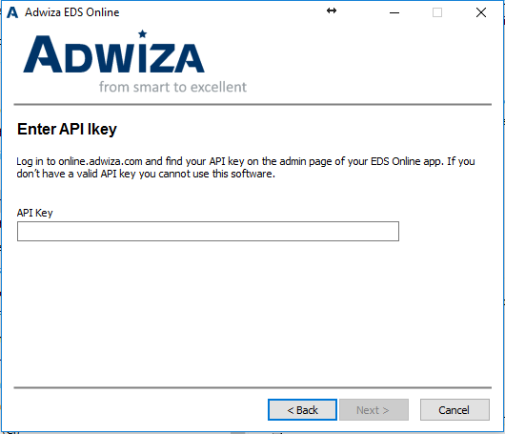

Input the API Key from the EDS Online Admin page on AOS and click next. You are not able to proceed if you do not have the API Key.

When the installer is finished it time to start the EDS Designer

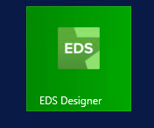

Starting the EDS Design for the first time

When you start the EDS Designer you need to use your SuperOffice CRM Online credentials.

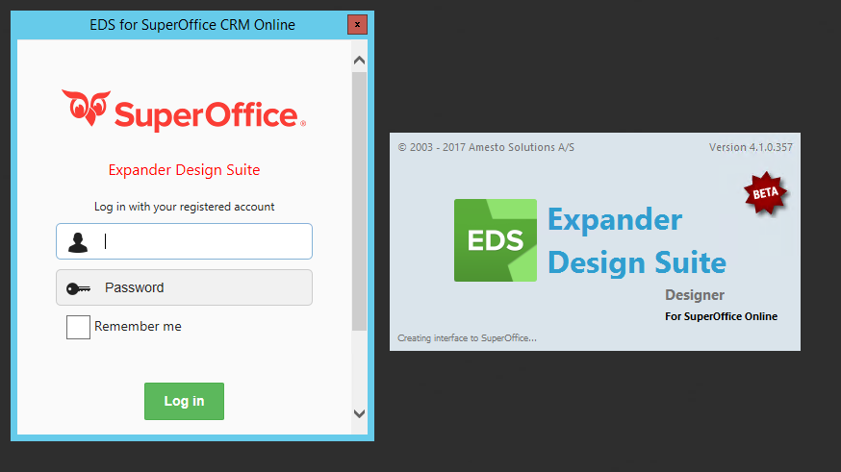

When you press login, the EDS Designer will initialize for the first time, and you are now ready to use the EDS Designer to start creation your solution from scratch or importing one of the many standard solutions available.

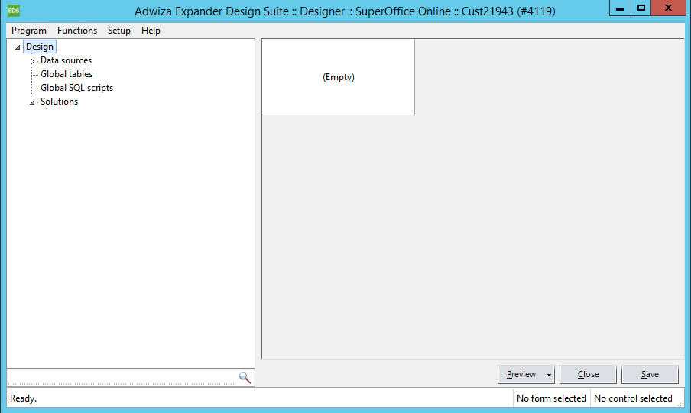

If you are not an EDS trained person, you should contact Amesto on [support@amestoapps.com](mailto:support@amestoapps.com)

# Setting up EDS Online

EDS consist of several processes working together. The map below shows the Technical map of the EDS components.

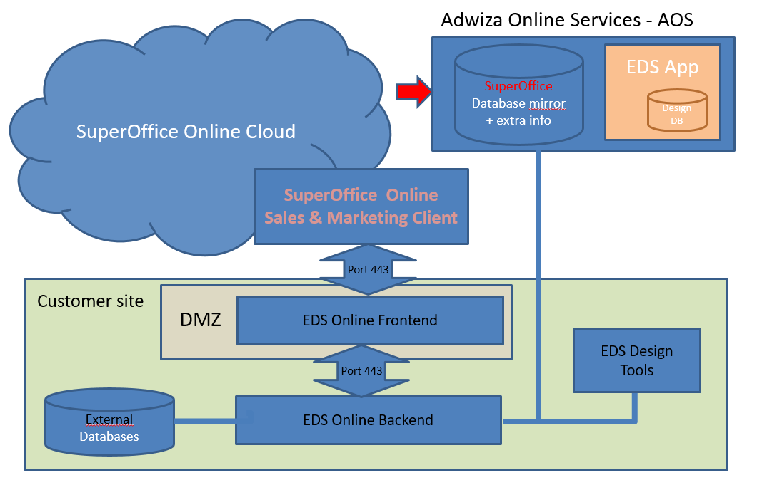

Almost all the functionality of the EDS On-premise versions is also a part of the EDS Online version. That means that most of the current solutions, build with the EDS On-premise version will work in the EDS Online version, making it easy to convert an On-premise SuperOffice Solution to an online equivalent. Check Appendix A in the last section of this guide to read about the difference in functionality between the on-premise and the online version of EDS.

# Deployment of the EDS Online Backend and EDS Online Frontend

**EDS Online BackEnd (Backend)**

The Backend web service takes care of handling the flow of data to and from the Mirror database located at the AOS Platform, and the local databases you want to integrate in the web panels of the SuperOffice CRM Online client.

**EDS Online FrontEnd (Frontend)**The Frontend serves the webpanel inside the SuperOffice CRM Online Client, and sends the request to the Backend, and returns the data to the Frontend.

Install the BackEnd website as close as you can to the On-premise data source you want to show in your EDS Solution, and the FrontEnd server on a server, where it can be accessed from the Internet. A SSL certificate is mandatory, to protect the EDS.FrontEnd, so you need to get one before you can get EDS working.

**EDS.Online.BackEnd and EDS.Online.FrontEnd install**

The 2 installers are located in the folder where you installed the EDS Designer, typically here:

C:\Program Files (x86)\Adwiza\Expander Design Suite Online\Servers

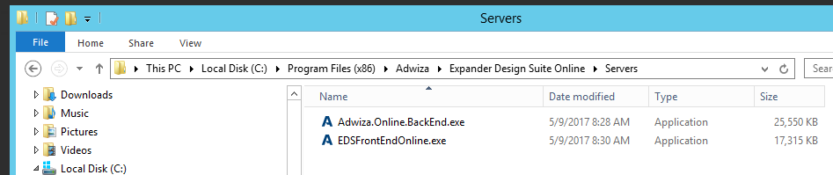

The install of the EDS.BackEnd is just next, next, next and you’re done. There is no configuration in this installer, because the configuration is done later from the EDS Designer.

When you install the FrontEnd server, you must specify where the BackEnd server is located

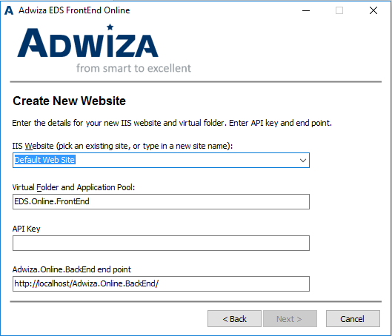

You also need to input the API found on the Admin page in the AOS platform.

If you have installed the BackEnd and FrontEnd on the same server, the above ‘Adwiza.BackEnd end point’ should be correct.

# BackEnd and FrontEnd Configuration

To configure the Backend and Frontend, you start the EDS designer and select ‘EDS.FrontEnd setup’ from the setup menu.

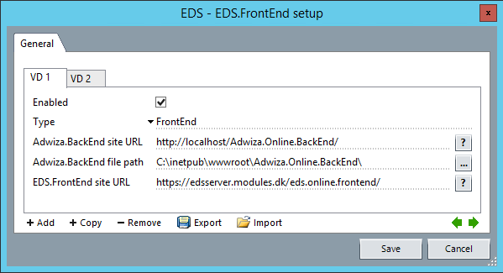

The above shows a typical setup of the EDS Frontend.

|  |  |
| --- | --- |
| **Field** | **Description** |
| Enabled | Activate and deactivate saving the configuration files |
| Type | FrontEnd = To support EDS.Frontend production  FrontEnd Standalone = The same as FrontEnd, but only to use for debugging purposes |
| BackEnd Site URL | The web endpoint of the BackEnd Server |
| BackEnd file path | The file path to the BackEnd server. This is used to save the configuration settings directly to the BackEnd server. |
| FrontEnd site URL | The main URL for accessing the EDS.FrontEnd. It will only work if the site is configured with a SSL certificate. |

**Best practice**Setup VD1 as the FrontEnd, and the VD2 as the FrontEnd (Test and Debug) and use the Enables checkbox to switch between them.

# **Frontend test**

You need to have at least one form in one solution to test the FrontEnd. Go to a solution and select a form. Press the arrow in the preview button in the designer, and the following menu will appear.

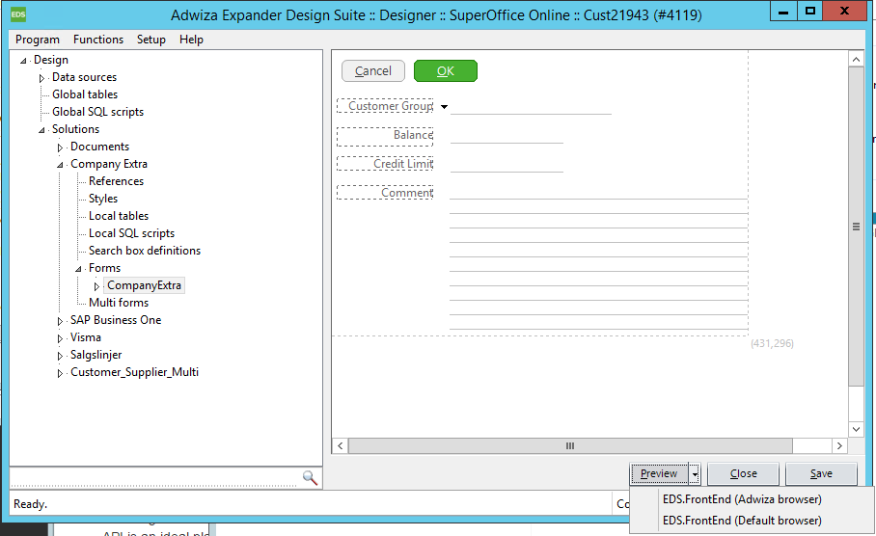

Choose the ‘EDS.FrontEnd (Default browser)’ to activate the Form. You default browser will launch with the EDS form inside.

# **EDS Security**

The security in EDS is based on the 2-factor security model that consist of the API key, issued by the AOS platform in combination with the server name of the server where the BackEnd service in running. The first time the BackEnd is activated the following message box appears.

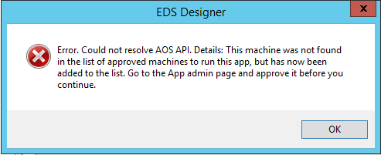

Login to the AOS platform, and go to the Admin page of the EDS App

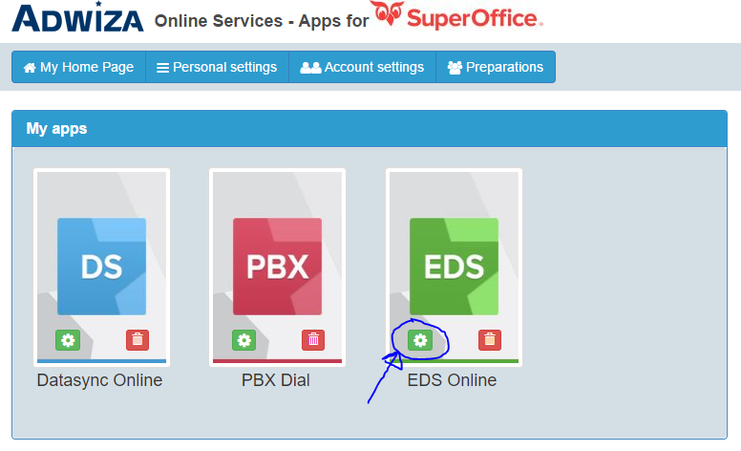

On the Admin page, you will find the server name of the server where the BackEnd Service is installed. Click on the Approve and the Enable sliders, and you have now authorized the server to service the EDS Frontend

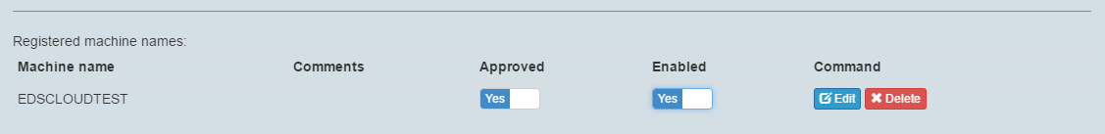

Now you can continue to test and setup the FrontEnd server.

# **Toubleshooting**

If you get the following error page (404) when you try to preview you form the most likely problem it that the installer could not register the EDS ISAPI dll that is needed.

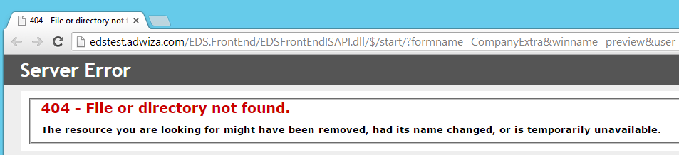

To register the dll manually in IIS point to the main node in the IIS Management tool, and choose ISAPI and CGI Restrictions. If this is missing, please add the CGI module as a feature of the IIS webservice on your webserver.

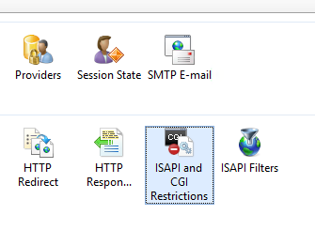

Add the EDSFrontEndISAPI.dll to the path, and allow it to Excute

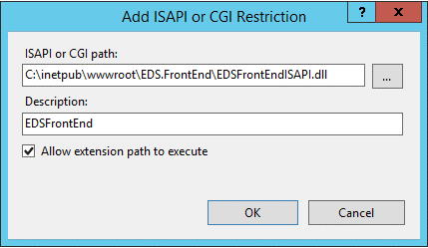

When all is setup correctly it should look like the screen below

