

**Online Signature for SuperOffice**

**System requirements and installation**

**Updated:** *1st March 2017*

**By:** *Claus Erik Brendstrup*

**Supplier:** *Amesto Solutions*

# Intro

Online Signature is a cloud service which requires a connection to connect your local SuperOffice database to the Adwiza App Store. This document refers to SuperOffice Windows and Web installations only (not SuperOffice CRM Online).

# System requirements

* SuperOffice Sales & Marketing for windows or web, version 7.5 or newer.
* A SuperOffice web service. This software component is a part of your SuperOffice maintenance program which makes a secure layer between your SuperOffice database and the internet, called an Endpoint. The server for the SuperOffice web services must have the Internet Information Server role installed.
* An Endpoint. An Endpoint is a URL to connect SuperOffice to the internet. A typical endpoint looks like this: “<https://soweb.domain.no/NetServer/Services75/>” or “<http://soweb.domain/Remote/Services75>”
* An open port for traffic. A rule in the firewall to route traffic at port 443 (HTTPS) from the Internet to the server. Can be limited only to accept traffic from our server. The 4 IP’s that needs to be allowed are 23.100.53.139, 23.100.53.152, 23.100.53.156 and 23.100.58.69

# Online Signature App Activation

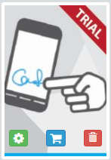The Online Signature App installation runs automatically during the configuration process. Principle for setup are:

1. A SuperOffice user with SuperOffice Admin rights must register at https://online.adwiza.com/, create a new account and log in.
2. Type in the credentials for the SuperOffice Endpoint at ”Change Settings”
3. ”Try” or ”Buy” the Online Signature App
4. Configure the Online Signature app at the green gear wheel icon.
5. Online Signature is ready to use.

# SuperOffice Endpoint

A SuperOffice Endpoint is the standard SuperOffice webservise used by SuperOfice Web, SuperOffice Service and Pocket CRM.

* Must be a SuperOffice 7.5 web service even though SuperOffice is version 8
* Create an active SuperOffice System User in the SuperOffice Admin application and use the credentials for the SuperOffice Endpoint login.
* Change settings and test the SuperOffice Endpoint at “Change Settings* at <https://online.adwiza.com/>
* The SuperOffice Endpoint publish URL syntax is <https://soweb.domain.no/NetServer/Services75/>
* The web service needs access to the SuperOffice SO_ARC achieve. Please check the following settings when running the SuperOffice web service: The impersonate user must have modify rights to the SO_ARC folder

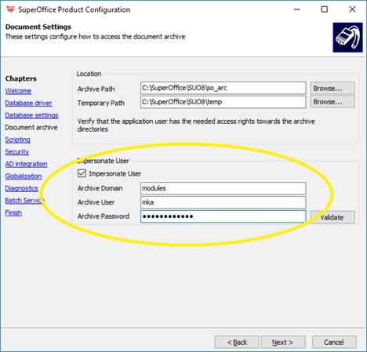



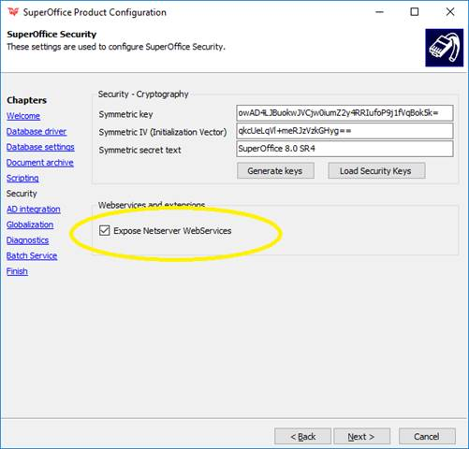

# Please note

* If the customer uses either SuperOffice Sales & Marketing for WEB, the SuperOffice Pocket CRM or SuperOffice Service or SuperOffice 8, the endpoint is already installed somewhere in the IT infrastructure.
* We recommend http**s** with a certificate to secure the communication between the SuperOffice and the Adwiza cloud platform.
* All communications in our platform are using https