1. Locate the PBX Dial client folder – usually

*C:\Program Files (x86)\SuperOffice\modules\Adwiza\PBX Dial*

1. Create a shortcut to the PBXDial.exe
2. Edit properties on the new shortcut and add /debug to the path

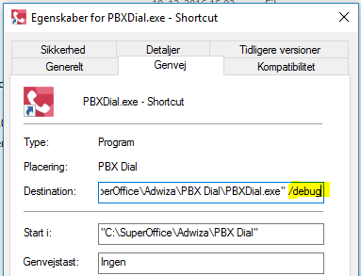

1. Start SuperOffice
2. Start PBX Dial via the newly created shortcut. (If PBX Dial was set to start with SuperOffice the new session will close the old one automatically)
3. A debug window will appear with information